The private repo which we created for CircleCI was called Continuous Integration and here are our results from the backend and frontend:

**Picture #1:** We created two jobs within the config.yml file, one for the frontend testing and the other for the backend testing



**Picture #2:** This picture shows all the passed and failed tests when running the backend tests on CircleCI:

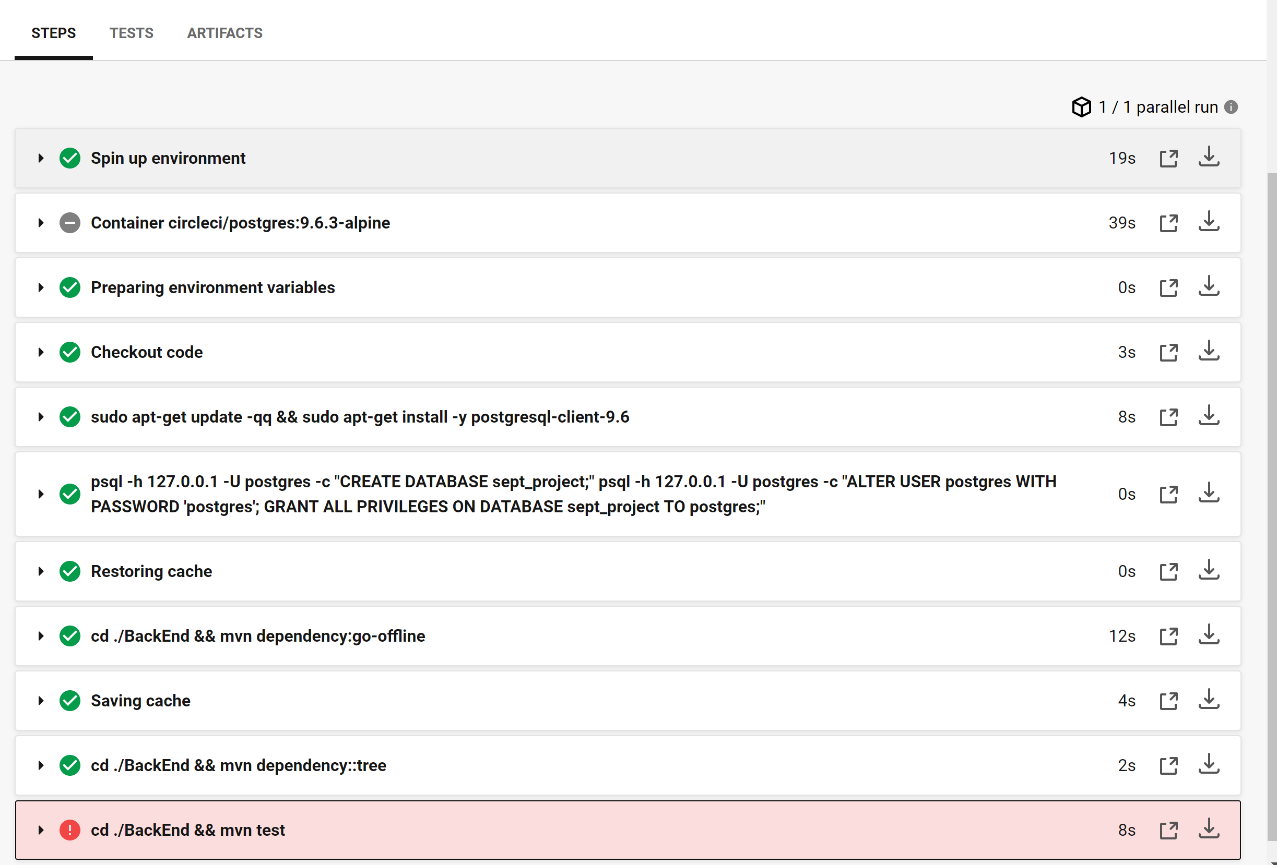

**Picture #3:** This picture shows all the passed and failed tests when running the frontend tests on CircleCI:

